LEAK detection of spacecraft In orbit USING Ultrasonic sensor array bY lamb waves

Lei Qi, Lichen Sun, Donghui Meng, Rongxin Yan, Wei Sun

Beijing Institute of Spacecraft Environment Engineering, Beijing, China

Abstract

With the increasing of human space activities, the number of space debris has increased dramatically, the possibility that spacecraft in orbit is impacted by space debris is growing. It is important to detect and locate the gas leak accurately and timely. In this paper, a leak detection method using ultrasonic sensor array is proposed. Firstly, the ultrasonic sensor array is used to detect the leak acoustic signal which propagates as Lamb wave through spacecraft structure. Then we apply beam forming algorithm to determine the direction of the leak source. Finally, we use cross section method to locate the leak source. The result shows that, the leak location error is less than 90mm in one square meter plate when the diameter of leakage hole is larger than 1mm. This method can meet the needs of leak detection for the spacecraft in orbit.

Index Terms—spacecraft, leak detection, ultrasonic sensor array, beam forming

1. Introduction

With the progress of space science technology and the development of the manned space engineering, the quantity of spacecraft in orbit is growing. The spacecraft is subjected to the test of space environment for a long time. It is important to strengthen the security protection in order to guarantee the normal operation of the spacecraft and the life safety of the astronauts. Spacecraft safety testing, system running state monitoring and risk protection system establishment have become the problems that need to study and solve immediately.
Now, a large number of micro meteor and space debris have been existed with the rapid development of the global aerospace industry. These micro meteor and space debris have become the major threat that destruct the seal performance of manned spacecraft^{[1]}. Space debris distributed in the altitude of 200 km to 800 km may impact frequently with space station and other spacecraft and causes the damage of the structure, even causes gas leak which will threaten the safety of the astronauts and even lead to the failure of the space mission. In 2007, the Endeavour was crashed by space debris in the task STS-118. The debris went through the radiator's panel and the shell of the heat control system, which led to severe leak of the space shuttle. The astronauts found and shot the structure damage by debris in 2008 during space walking of task STS-122&123^{[2]}.
Since 2000, NASA and other research institutions have carried out a lot of research work on leak detection of spacecraft in orbit^{[3-6]}. Ultrasonic leak detection technology has gained a lot of attention because of its high sensitivity and easy implementation. Since 2005, Holland of Iowa University has carried out researches on cross-correlation techniques to determine air leakages on the International Space Station (ISS) ^{[7-9]}. In the study, two 16×16 sensor arrays were applied to locate the leak. Large number of sensors and millions of data samples lead to a time and financial consuming task. G.C. McLaskey^{[10]} firstly applied the beam forming techniques to the method of acoustic emission for damage detections. The specimen tested in their experiment was a steel reinforced concrete bridge ramp instead of a thin plate. So, their work was based on Rayleigh wave theory, in which P-wave and R-wave were discussed instead of Lamb wave. And the wave velocity shows no dispersion in mediums of their experiments. Tian He^{[11]} tested on a thin plate equipped with near-field beam forming analysis, which was suitable for Lamb wave theory. Burst AE signals created by breaking a mechanical pencil lead on the surface of the specimens were applied in their tests and the propagation speed of the signal was obtained by time difference of arrival (TDOA) techniques. This method is less than ideal for leak-generated continuous signal because the phase speeds of the continuous signals determined by TDOA lack reliability and the dispersion characteristic of Lamb waves are not taken into consideration. However, the difficulties of using beam forming techniques for AE signal processing exactly lie in the confirmation of phase speeds due to its dispersion.
The method proposed in this paper concentrated on the study of dispersion curves of Lamb waves. Signals, of which the frequency components were 190-200 KHz and its corresponding phase speed 1732 m/s, were chosen to acquire the time delay matrixes. Once the time delay matrixes were given, beam-power-versus-azimuth curves can be drawn, from which the best estimate of the direction of the source was determined.

2. Theory

Figure 1. Leak locating with beam forming method
Leak signal belongs to continuous signal. The traditional time difference of arrival (TDOA) cannot locate this kind of signals because arrival time cannot be obtained directly. But beam forming method can position the leakage. Location of the acoustic emission source can be realized by base on time delay beam forming technology of multi-sensor array. Its directional principle diagram is shown in Figure 1.
Calculate the angles θ₁and θ₂ from the sound source incident using beam forming algorithm. According to direction angle and the distance between sensor arrays, the coordinates (x,y) of acoustic emission source can be calculated as shown in the following type
(1)
The principle of beam forming algorithm is that data from each array element in the array is linear time invariant filtered and summed. The output of the beam is obtained at last. The flow chart of beam forming processing is shown in Figure 2.
Figure 2.The signal flow chart of beam forming
To sensor array composed of n sensors, its response of signal can be described as
(2)
In this expression, u_{i} is the ith output signal in sensor array, d_{i} is the time delay which leak signal arrives in each sensor of array. Its value depends on the distribution of the array and the vector s which contains the direction of the sound wave propagation and the directivity of propagation velocity of acoustic signal under this mode. Leak signal produced by the same leak is consistent, but the noise signal is random, so the SNR of the signal output of sensor array can be improved through the signal superposition technique. The noise power of acoustic beam can be further derived by this method through calculating the moving mean square value of sensor array output with time. Derivation formula is as follows.
(3)
The value of computing time window T is not only large enough to obtain most of the acoustic emission signal produced by leak, but also avoids the impact of edge reflection acoustic signal as far as possible. It depends on the parameters of the structure to be tested. Different time delay respectively corresponds to different pointing angles of array. According to the relation of the delays and the angles of antenna array, we can get the amplitude curve, which is shown in Figure 3. The angle corresponds to the largest amplitude in the curve is the incident angle from leak source to the sensor array. When two or more sensor arrays are combined, the source can be located in two dimensions by triangulation.
Figure 3. The relationship curve between beam-forming angle and signal energy.

3. Experimental setup

The experiment system, as shown in Figure4, consists of three parts —the aluminum alloy test plate, the vacuum simulation system and the leak signals acquisition system.
The aluminum alloy plate, which is the same as the hulk of the spacecraft, is 1 m×1 m in diameter, and 2 mm thick. A hole, 1mm in diameter, is drilled at the center of the plate. Equipped with the vacuum simulation system, the hole simulates the air leakage on the ISS. Several lines were drawn on the plate to indicate the position of the sensor array.
The vacuum simulation system acted as evacuation device consists of the vacuum-to-plate adapter, exhaust pipe, vacuum pump and the vacuum meter. After putting the vacuum-to-plate adapter under the leak hole of the plate, turn on the valve and wait until the adapter is attached tightly to the plate. Adjust the valve according to the indicated value of the vacuum meter.
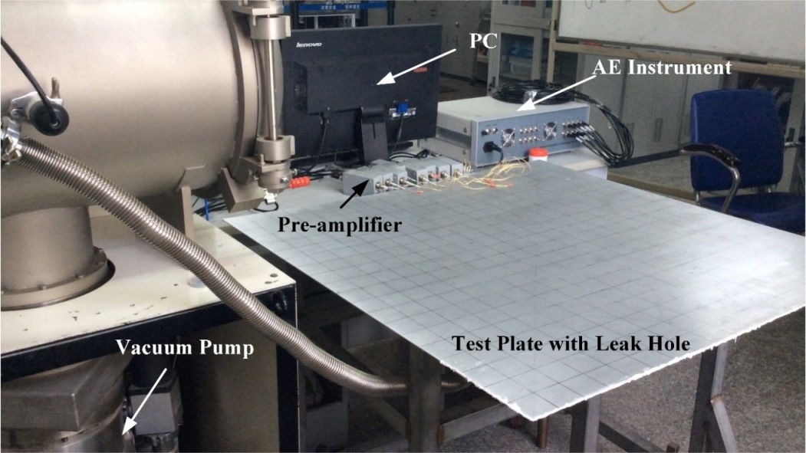
Figure4. The experimental setup
The leak signals acquisition system, is made up by AE sensor array, customized fixture for the sensor array, pre-amplifiers and AE instrument. The sensor has a stable frequency response from 100 kHz to 400 kHz. Eight sensors, numbered from 0 to7 and placed in ‘L’ as shown in Figure5. AE instrument samples the data at the rate of 3 MPS. Leak signals are acquired by array sensor first, and then amplified by 8 pre-amplifiers by 40 dB. At last, signals are transmitted to the AE instrument and restored in disc by PC for later processing.

Figure5. The position of sensor array
A leak hole located at (0, 0), 1 mm in diameter, is drilled before on the plate, and it is marked as red circular in Figure5. Equipped with the air exhaust system, air evacuated from the hole to the vacuum-to-plate adapter can simulate the leakage. Leak-generated ultrasounds spreading through the plate as guided Lamb waves were acquired by the array sensor to direct the leak source. The corresponding azimuthal directions of leak at position A, B, C, D, E, F, G, H and I were 9°, 13°, 20°, 24°, 31°, 45°, 57°, 73° and 79°, respectively. The distance from the sensor array to the leak source maintained at R= 300 mm during the experiment.

4. Results and discussions

From the beam forming theory, the identical amplitude, phase and frequency responses of array elements are critical to ideally eliminate the different location sensitivities of sensor array. If some array elements have higher power donations than others or sensor elements have different phase shifting to the inputs, when time-delayed and summed-up, the inputs from these sensors lead to an undesired location result. Based on this phenomenon, data from array elements are normalized by energy firstly in experiments to relieve different amplitude responses, while phase shifting leaves to be resolved. Due to the dispersion characteristics of Lamb waves, signals of different frequency components have different phase speeds, and the phase speed is assumed to maintain the same within narrow frequency bands. Different from the TDOA methods proposed in other papers, distinguishing phase speeds according to narrow band frequencies in one mode is firstly applied to our experiments. Thus, the data are then processed by narrowband pass filtering into 10 frequency bands: 150-160kHz, 160-170kHz,…, 240-250kHz. And the corresponding phase speeds of different frequency components are acquired by dispersion curves for test plate. For the low frequency-thickness product, between 0.3 MHz∙mm and 0.5 MHz∙mm, in our experiment, only two modes of waves (A0 mode and S0 mode) exist. Because the delay matrixes calculated by the phase speeds of S0 mode wave have poor agreements with the actual direction of arrival, only A0 mode signals are discussed in the rest of the paper. The green dotted rectangular in Figure6 shows the range of frequency-thickness products and phase speeds in our experiments. Table.1 listed the value of the frequency and its corresponding phase speed s_{p} of A₀ mode. The phase speed is acquired by the central frequency f, which is the mean value of the frequency bands. Within the frequency band, the phase speeds are assumed to be the same.
Table1. Phase speeds of different frequency bands of A₀ mode signals
Frequency band (kHz) | Phase speed s_{p}(m/s) | Frequency band (kHz) | Phase speed s_{p}(m/s)
150-160 | 1581 | 200-210 | 1765
160-170 | 1621 | 210-220 | 1797
170-180 | 1661 | 220-230 | 1827
180-190 | 1696 | 230-240 | 1857
190-200 | 1732 | 240-250 | 1885
Once the phase speeds and the geometry of the sensor array are given, the time delay matrix d_{i,s} can be obtained. After the d_{i,s} are given, beam-power-versus-azimuth curves are accessed by Eq. (3). When the power gets its maximum, the corresponding assumed azimuth is the best estimate of the actual direction of arrival. Figure6 shows the beam-power-versus-azimuth curve. The actual azimuthal direction of arrival is 31° and the corresponding assumed azimuth is 28°, from the figure, when the power gets its maximum. So the location result of the leak source is 28°. Conclusions are also derived from the figure that lead by the interferences from reflected waves and inconformity of sensors, several grating lobes exist, and in some cases, it worsens the location accuracy rate when its value gets larger than the main lobe.
Figure6. Beam-power-versus-azimuth curves
The absolute values of location errors are calculated under different frequency bands and the corresponding phase speeds at the above 9 positions. Apparently, signals between 190 kHz and 200 kHz perform best among the 15 frequency bands, of which the mean location error is 2.28°. Therefore, signals between 190 kHz and 200 kHz are chosen to process the total 180 data series, and the scatter diagram of location errors are illustrated in Figure7. Each position has been orientated for 20 times, so there are 20 dots at each position. The triangles show the absolute values of average location errors at each position, which is less than 5°. And the green dotted lines in the figure represent 90% confidence intervals, which is less than 5°. In one square meter plate, 5° angle error is equal to 87.4mm location error. So the conclusions can be derived that, evaluated by location errors less than 90mm, the accuracy rate of the approach is 90%.
Figure7. The scatter diagram of location errors at 9 positions

5. Conclusions

This paper comes up a novel approach to determine the phase speeds of different frequency components of signals by solving Rayleigh-Lamb equations. Compared to applying a uniform propagation speed obtained by experiment regardless of signal frequency components, this method has higher reliability. In our experiments, the sensor array measures the leak-noise generated ultrasound propagating through the test plate. And then the signals are processed by the following steps:
(a). The data are processed by narrow band pass filtering into 10 frequency bands. With dispersion curves of Lamb wave, the corresponding phase speed for each frequency components is confirmed. And the phase speed within the bandwidth is considered to maintain uniform.
(b).By analyzing the location results of beam-power-versus-azimuth curves under different phase speeds, and choose the signal components of 190-200 kHz to locate the leak. And the corresponding phase speed is 1732 m/s.
(c).The experiment result shows that, evaluated by location errors less than 90mm, the accuracy rate of the approach is 90%. However, the multimodal distribution of beam-power and different location sensitivity of sensor array caused by the inconformity of sensors decrease the accuracy rate of the direction result, which leaves to be resolved.

6. Acknowledgments

This research was funded by National Nature Science Fund of China (No. 61903040,61973227), State key laboratory of precision measuring technology and instruments (Pilab1706), Tianjin Key R&D Program (No. 19YFSLQY00080)

7. References

[1] E. Stansbery, J. Foster, C. Stokely, Haystack Orbital Debris Radar Measurements Update, The Orbital Debris Quarterly News, 2005(9-1): 3-5.

[2] Lei Qi, Zhoumo Zeng, Lichen Sun, An Impact Location Algorithm for Spacecraft Stiffened Structure Based on Posterior Possibility Correlation. Sensors. 2020(20)2:368.

[3] Dykema J A, Anderson J G. A Methodology for Obtaining on-orbit SI-traceable Spectral Radiance Measurements in the Thermal Infrared[J]. Metrologia, 2006, 43(3): 287-293.

[4] Klar A A, Linker R, Herrmann S. Leakage-induced pipeline stressing and its potential detection by distributed fiber optic sensing[J]. Geotechnical Engineering, 2019, 50(2): 85-90.

[5] Wang G, Li N, Li W, et al. Important Improvements of Helium Mass Spectrometry Test for Sealability[J]. Journal of Electrical and Electronic Engineering, 2019, 7(1): 8-22.

[6] Lei Qi, Zhoumo Zeng, Yu Zhang, Research on Leakage Location of Spacecraft in Orbit Based on Frequency Weighting Matrix Beam forming Algorithm by Lamb Waves, Appl.Sci. 2020(10),3:1201.

[7] Stephen D. Holland, Ron Roberts, D. E. Chimenti, Leak Detection in Spacecraft using Structure-borne Noise with Distributed Sensors, Applied Physics Letters. 2005 (86): 1-4.

[8] Holland S D, Roberts R, Chimenti D E, et al. An ultrasonic array sensor for spacecraft leak direction finding[J]. Ultrasonics, 2006, 45(1-4): 121-126.

[9] Stephen D. Holland, D. E. Chimenti, Leak Detection Using Structure-borne Noise, Iowa State University Patents (2010), 2-7.

[10] Gregory C.McLaskey, Steven D. Glaser, Beamforming Array Techniques for Acoustic Emission Monitoring of Large Concrete Structures, Journal of Sound and Vibration 2010 (329): 2384-2394.

[11] Tian He, Qian Pan, Near-field Beamforming Analysis for Acoustic Emission Source Localization, Ultrasonics, 2012 (52): 587-592.

