Artificial Intelligence based region of interest enhanced video compression
Palanivel Guruva reddiar and Praveen Prasad
Intel Corporation
5000 W Chandler BLVD
Chandler, AZ 85226, USA
{Palanivel.Guruvareddiar,Praveen.Prasad}@intel.com

With the rise of artificial intelligence over the past few years, object detection and tracking have become common workloads for end-to-end video systems. Fig.1. shows a distributed computing architecture using artificial intelligence. Smart cameras mounted on the freeways monitor for incidents like speeding and when such an incident occurs, it performs video analytics to identify the vehicle. It then transmits the results of the video analytics as well as the compressed video to the Network Video Recorder (NVR). The NVR performs more advanced analytics to detect attributes such as vehicle make and model, license plate number as well as the color of the vehicle. The enhanced video analytics information along with the compressed video will be transmitted to the data center that performs compute-intensive video analytics to recognize the face of the driver and match the results with a known data base such that appropriate action could be initiated.
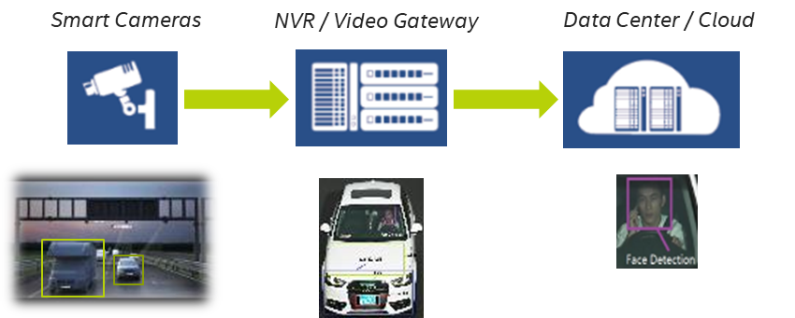
Fig.1. Distributed computing architecture using Artificial Intelligence
Our proposed approach detects and preserve the regions of interest at the camera to improve the overall accuracy of the distributed use case. As shown in Fig.2, our approach produces video bitstream with license plate characters well preserved that will result in improved license plate recognition accuracy at the NVR and cloud servers.
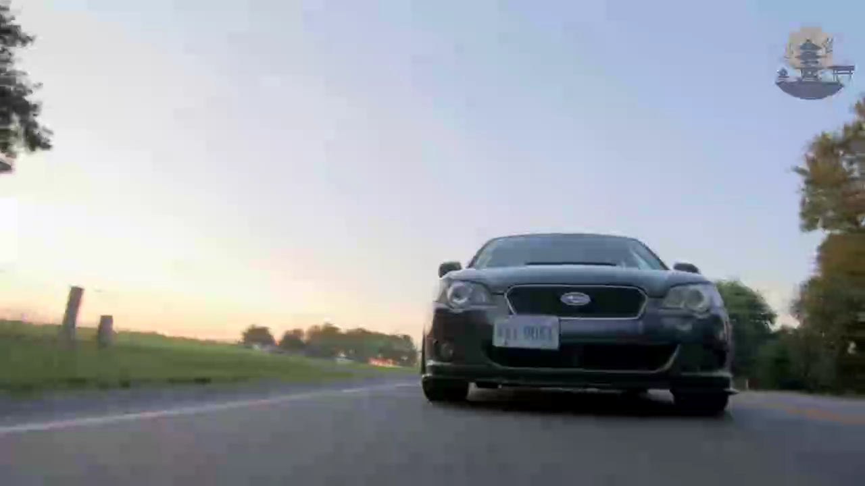
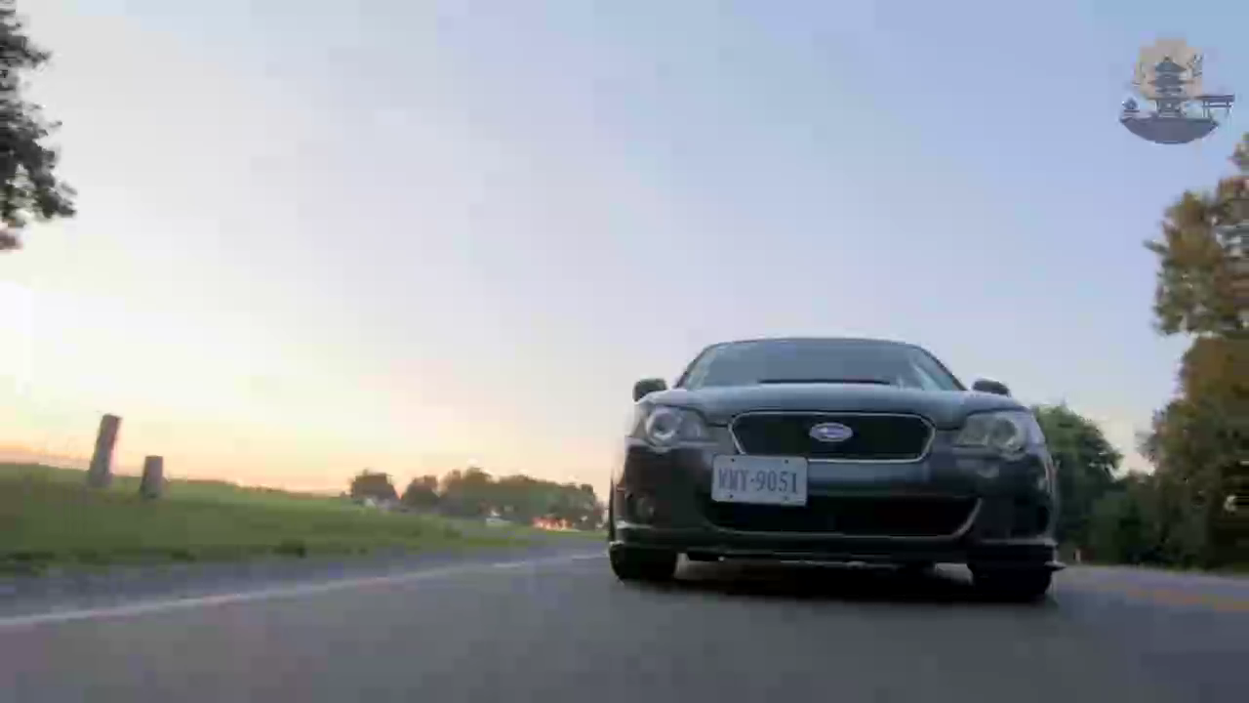
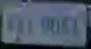
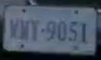

Fig.2. Left - Sample encoded frame with no ROIs preserved and Right – Sample Encoded frame with ROIs preserved. License plates after encoding have been overlaid on the images for illustration purposes only

